2018-2019 Soccer Season
Mavericks Soccer YARD SIGNS Return Order form and payment to Coach Womack or Coach Kidd
Checks Payable to MHS Soccer Booster Club
Sign $20.00 (includes stake)

Player Name: _________________________________________
Email Address: _________________________________________
Phone: _________________________________________

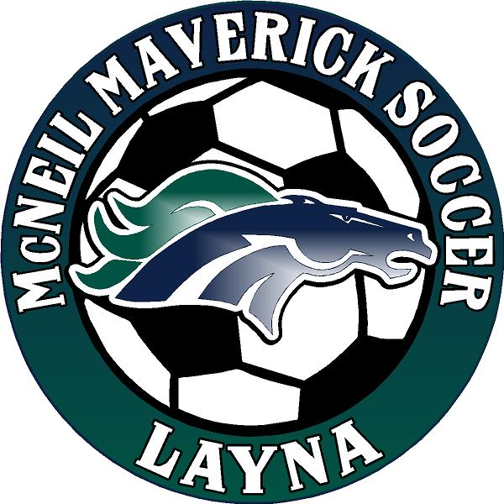

Yard Sign Name: ___________________________

Quantity: ________ Total Paid: ________

